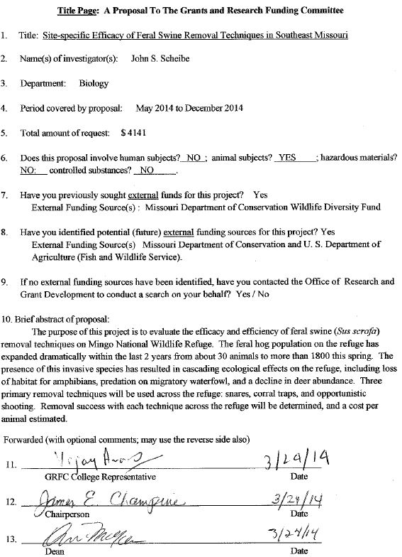
PROJECT DESCRIPTION

- Problem

Feral swine (Sus scrofa) have established populations in Southeast Missouri, and some of those populations are expanding at an alarming rate. On Mingo National Wildlife Refuge, our preliminary data show the population has grown from about 30 animals 2 years ago, to roughly 1800 animals today. Because they are omnivorous, have a destructive foraging behavior and are highly fecund, they have the potential to initiate cascading ecosystem effects that can only be mitigated by their removal. Because habitat is extensively fragmented in Southeast Missouri, protection of our remaining natural areas from this pest will be important for the ecological stability of the region.
2. Objectives
A variety of techniques have been developed to control and eradicate feral swine. However, the efficacy and efficiency of these techniques varies greatly depending on habitat structure, natural forage availability, presence of predators and human activity. Thus, it is necessary to determine that technique which is most cost effective for any given site. Site-specific feral swine control strategies must be developed for all managed areas to achieve maximum return on worker effort and cost. In this project, the efficacy of three commonly used feral swine removal techniques (trapping, snaring, and shooting) will be evaluated for Mingo National Wildlife Refuge (MNWR). I have five years of continuous camera trap data as well as detailed GIS models for the refuge, making it possible to address three objectives for the site. Objective 1: test for differences in technique success (including differences among trap types) among areas with widely varying habitats. Results from this portion of the study will allow me to address Objective 2: development of a management plan that incorporates technique success and costs per unit effort for ongoing swine control on MNWR. Throughout the study, body condition and natural history data for swine will be collected so that a detailed understanding of this biological invasion can be developed (Objective 3). This will improve our understanding feral swine invasion processes locally, and when compared with invasions across the country, may provide insight for large scale control strategies.
3. Literature Review
The Missouri Department of Conservation Feral Hog Fact Sheet (mdc.mo.gov/node/17158; last accessed March 20, 2014) notes that a feral hog is “any Russian or European wild boar that is not conspicuously identified by ear tags or other markings (like brands or collars), that is roaming freely on public or private lands without the landowner’s permission.” Populations in Missouri grew dramatically beginning in the early 1990’s and are now estimated to be well over 10,000 animals. Because sows are capable of producing at least 2 litters each year, with 6 to 10 piglets in each litter, dramatic increases in population size are possible. Feral swine are capable of extensive damage to natural and private lands and are recognized as a pest species (Barrett and Birmingham, 1994; Mayer et al., 2014; Pierce II and Martensen, 2009) not only in North America, but in New Zealand and Australia as well (Dzieciolowski et al. 1992).

The foraging mode used by feral swine involves rooting, a behavior which results in significant disturbance of soil layers (Seward et al. 2004) with consequent effects on seedlings, emergent vegetation and soil arthropods (Cushman et al. 2004, Gomez et al. 2003 Sweitzer and Van Vuren 2002). Because swine move through the habitat in ‘sounder groups’ (sow with offspring and kin and several boars) consisting of as many as 16 to 18 individuals, foraging in a particular area can result in extensive habitat alteration (Massei and Genov 2004). Because swine lack sebaceous glands, they wallow (Pierce II and Martensen 2009) resulting in additional habitat modification. The presence of swine causes often times dramatic changes to the structure of the habitat and consequently, the structure of plant and animal communities (Engeman et al. 2004). These changes are sometimes expressed most dramatically by collapsing deer and squirrel populations (a result of acorn use: Focardi et al. 2000) in areas where feral hogs are established.

The cascade of ecological effects caused by feral swine has prompted efforts in North and South America (Coblentz and Baber, 1987), Europe (Brauer et al, 2006; Maillard and Fournier 1995), Australia (Saunders et al. 1990, Twigg et al. 2005) and New Zealand (Dzieciolowski et al, 1992) to control their feral swine populations. These efforts have been as varied as aerial gunning (Campbell et al. 2010; Choquenot et al. 1999), use of dogs in conjunction with shooting (Caley and Ottley 1995; Maillard and Fournier 1995), trapping, poisons and contraception and use of judas pigs followed by shooting (Campbell et al. 2005; McIlroy et al. 1993; Saunders et al. 1990; Wilcox et al. 2004). The efficacy of each method is dependent on unique characteristics of the habitat, the structure of source populations, and experience of the hogs in highly persecuted populations with control efforts (Keuling et al. 2008; Littauer 1993). Thus, the most effective and efficient technique is site specific.

A few efforts at control of feral swine have managed complete eradication (Cruz et al 2005; Lombardo and Faulkner 2000; McCann and Garcelon 2008; Schuyler et al. 2002). However, in each of these cases, the populations were either closed to immigration of new animals (island populations) or the area (Pinnacles National Monument) was effectively enclosed with an electric fence. Complete eradication is not possible in most systems, and certainly not at MNWR where the area is large, and there is occasional illegal release of new animals into the population. This necessitates a long term program for control, and therefore a methodology that is cost effective.

In this project, I supplement control efforts already underway (aerial gunning, Judas pigs, dogs and shooting) through the MDC and USFWS with long term, less costly control efforts (traps and snares, opportunistic shooting). In conjunction with the MDC and USFWS, we have established 8 corral traps (4 rooter gate, 4 C-gate) in each of four target areas on MNWR, as well as a trap line of hog snares in each area.

Literature Cited

Barrett, R. H. and G. H. Birmingham. 1994. Wild Pigs. Pages 65-70 in Prevention and Control of Wildlife Damage (S. E. Hygnstrom, R. M. Timm, and G. E. Larson eds.). Great Plains Agriculture Council, Wildlife Committee, Cooperative Extension Service, Institute of Agriculture and Natural Resources, University of Nebraska, Lincoln.

Brauer, A., E. Lange, and V. Kaden. 2006. Oral immunisation of wild boar gainst classical swine fever: uptake studies of new baits and investigations on the stability of lyophilised C-strain vaccine. European Journal of Wildlife Research 52:271–276.

Caley, P., and B. Ottley. 1995. The effectiveness of hunting dogs for removing feral pigs (Sus scrofa). Wildlife Research 22:147–154.

Campbell, K. J., G. S. Baxter, P. J. Murray, B. E. Coblentz, C. J. Donlan, and G. V. Carrion. 2005. Increasing the efficacy of Judas goats by sterilization and pregnancy termination. Wildlife Research 32:737–743.

Campbell, T. A., D. B. Long and B. R. Leland. 2010. Feral swine behavior relative to aerial gunning in southern Texas. Journal of Wildlife Management 74(2): 337-341.

Choquenot, D., J. Hone, and G. Saunders. 1999. Using aspects of predator–prey theory to evaluate helicopter shooting for feral pig control. Wildlife Research 26:251–261.

Coblentz, B. E., and D. W. Baber. 1987. Biology and control of feral pigs on Isla Santiago, Galapagos, Ecuador. Journal of Applied Ecology 24:403–418.

Cruz, F., C. J. Donlan, K. Campbell, and V. Carrion. 2005. Conservation action in the Galapagos: feral pig (Sus scrofa) eradication from Santiago Island. Biological Conservation 121:473–478.

Cushman, J. H., T. A. Tierney, and J. M. Hinds. 2004. Variable effects of feral pig disturbances on native and exotic plants in a California grassland. Ecological Applications 14:1746–1756.

Dzieciolowski, R. M., C. M. H. Clarke, and C. M. Frampton. 1992. Reproductive characteristics of feral pigs in New Zealand. Acta Theriologica 37:259–270.

Engeman, R. M., H. T. Smith, R. G. Severson, M. M. Severson, S. A. Shwiff, B. Constantin, and D. Griffin. 2004. The amount and economic cost of feral swine damage to the last remnant of a basin marsh system in Florida. Journal for Nature Conservation 12:143–147.

Focardi, S., D. Capizzi, and D. Monetti. 2000. Competition for acorns among wild boar (Sus scrofa) and small mammals in a Mediterranean woodland. Journal of Zoology London 250:329–334.

Gomez, J. M., D. Garcia, and R. Zamora. 2003. Impact of vertebrate acorn- and seedling-predators on a Mediterranean Quercus pyrenaica forest. Forest Ecology and Management 180:125–134.

Keuling, O., N. Stier, and M. Roth. 2008. How does hunting influence activity and spatial usage in wild boar Sus scrofa L. European Journal of Wildlife Research 54:729–737.

Littauer, G. A. 1993. Control techniques for feral hogs. Pp. 139–148 in Feral swine: a compendium for resource managers (C. W. Hanselka and J. F. Cadenhead, eds.). Texas Agricultural Extension Service, Kerrville.

Lombardo, C. A., and K. R. Faulkner. 2000. Eradication of feral pigs, (Sus scrofa) from Santa Rosa Island, Channel Islands National Park, California. Pages 300–306 in D. R. Browne, K. L. Mitchell, and H. W. Chaney, editors. Proceedings of 5th California islands symposium. U.S. Department of the Interior, Mineral Management Services Pacific Outer Continental Shelf Region, study MSS99–0038, Washington, D.C., USA.

Maillard, D., and P. Fournier. 1995. Effects of shooting with hounds on size of resting range of wild boar (Sus scrofa) groups in Mediterranean habitat. Ibex Journal of Mountain Ecology 3:102–107.

Massei, G., A. Jones, T. Platt, and D. P. Cowan. 2009. Iophenoxic acid as long-term marker for wild boar. Journal of Wildlife Management 73:458–461.

Mayer, J., G. Yarrow, T. Thom, N. Myers, D. Lenard. 2014. South Carolina’s Growing Wild Hog Problem: Recommendations for Management and Control. Technical Report, South Carolina Wild Hog Task Force. Savannah River National Laboratory. 5 pp.

McCann, B. E., and D. K. Garcelon. 2008. Eradication of feral pigs from Pinnacles National Monument. Journal of Wildlife Management 72:1287–1295.

McIlroy, J. C., E. J. Gifford, and R. I. Forrester. 1993. Seasonal patterns in bait consumption by feral pigs (Sus scrofa) in the hill country of Southeastern Australia. Wildlife Research 20:637–651.

Missouri Department of Conservation. Feral Hog Fact Sheet. mdc.mo.gov/node/17158

Pierce II, R. A. and R. Martensen. 2009. Feral Hogs in Missouri: Damage Prevention and Control. Technical Report G 9457, University of Missouri Agricultural Extension Service.

Saunders, G., B. Kay, and B. Parker. 1990. Evaluation of a warfarin poisoning programme for feral pigs (Sus scrofa). Australian Wildlife Research 17:525–533.

Schuyler, P. T., D. K. Garcelon, and S. Escover. 2002. Eradication of feral pigs (Sus scrofa) on Santa Catalina Island, California, USA. Pages 274–286 in C. R. Veitch and M. N. Clout, editors. Turning the tide: the eradication of invasive species. World Conservation Union, Species Survival Commission, Invasive Species Specialist Group, Gland, Switzerland and Cambridge, United Kingdom.

Seward, N. W., VerCauteren, K. C., Witmer, G. W., and Engeman, R. M. 2004. Feral Swine Impacts on Agriculture and the Environment. 2004. Sheep & Goat Research Journal. Paper 12. http://digitalcommons.unl.edu/icwdmsheepgoat/12

Sweitzer, R. A., and D. Van Vuren. 2002. Rooting and foraging effects of wild pigs on tree regeneration and acorn survival in California’s oak woodland ecosystems. Pages 218–231 in R. B. Standiford, D. McCreary, and K. L. Purcell, technical coordinators. Proceedings of the 5th symposium on oak woodlands: oaks in California’s changing landscape. U.S. Forest Service, General Technical Report PSW-GTR-184. Pacific Southwest Research Station, Albany, California, USA.

Twigg, L. E., T. J. Lowe, G. R. Martin, and M. Everett. 2005. Feral pigs in north-western Australia: basic biology, bait consumption, and the efficacy of 1080 baits. Wildlife Research 32:281–296.

Wilcox, J. T., E. T. Aschehoug, C. A. Scott, and D. H. Van Vuren. 2004. A test of the Judas technique as a method for eradicating feral pigs. Transactions of the Western Section of the Wildlife Society 40: 120-126.

4. Procedure
This project is a joint effort between Southeast Missouri State University, the Missouri Department of Conservation (MDC) and the U. S. Fish and Wildlife Service (USFWS) at Mingo National Wildlife Refuge. All of the work described here is coordinated through all three entities, and involves numerous personnel from SEMO (J. S. Scheibe and his graduate students Anna Weyers and Kacie Bauman), MDC (Kaleb Neece and Mark McClain) and MNWR (Brad Pendley). The MDC is providing guidance, materials, and logistic support and the USFWS is providing site access, housing, technical support, GIS and digital elevation models, and personnel for shooting, while the Missouri Department of Natural Resources and the U. S. Army Corps of Engineers is providing site access and coordination for removal activities.
Through the use of continuous camera trap data over the last five years, we have identified four core areas on MNWR that have experienced the greatest use by feral swine and/or represent areas that swine must traverse as they move through the refuge (Fig. 1). Within each of these four large areas, we have established a corral trap with a rooter gate (Fig. 2), a corral trap with a C-gate (Fig. 3) and a trap line of snares (Fig. 4). The traps consist of panels of welded wire supported by fence posts, with a point of entry consisting of either a rooter gate or a C-panel.
Traps are baited with corn several times each week, and all captured hogs are shot and removed by MDC or USFWS personnel. Similarly, snare trap lines are baited with corn and checked three or more times each week. Captured animals are shot and removed by MDC and USFWS personnel. Morphological data (head and body length, tail length, hind foot length, ear length, girth, sex and reproductive status are recorded for each removed animal. Hair samples are collected for genetic assays to determine the population of origin and if deliberate releases of new animals into the population occur. Also, blood samples are taken for disease assays.
The USFWS has employed a professional hunter with dogs to shoot feral swine on MNWR for 6 weeks. All kills and costs are recorded so that we can compute the cost per hog removed. Because the use of dogs on the refuge disrupts normal hog movements, we also record reduced hog activity relative to traps and snares. Similarly, the MDC has an aerial gunning team that has been deployed on MNWR during periods of snow cover in an effort to remove large numbers of animals opportunistically. We have been provided with all costs for personnel, helicopter expenses, ammunition etc. for these activities, as well as numbers of animals removed, and can thus also compute cost per hog removed.
Time invested for all field work (e.g., setting traps or snares, hunting/shooting, travel) will be tabulated during the course of the study and estimates of worker hours per pig removed for each technique will be calculated. With the exception of aerial gunning, all removal techniques will be employed concurrently to avoid bias due to temporal variation in swine activity. Traps and snares will be operated on the same nights and hunting bouts will occur during the same 24 hour periods. Additional field workers may be employed to accomplish simultaneous deployment of techniques, including; MDC staff, SEMO representatives and USFWS personnel, as available. Estimates of worker hours invested per pig removed by technique will be converted to monetary values based on average hourly wages for economic damage estimate purposes.
A general linear model will be constructed in SAS to evaluate the three removal methods (traps: rooter gate and C-gate), snares and shooting (aerial, opportunistic and hunting with dogs). Because hog behavior is seasonal and because there are interactions between hunting and trap success, the model will be a multivariate time series model with interaction terms. The model will be presented in a meeting with USFWS and MDC managers in an effort to develop a hog management plan for MNWR. Because the refuge has competing interest groups (hunting, fishing, wildlife viewing etc.) the results generated by this project must be considered in context with other interests and constraints. The morphological, genetic and disease data will be used to develop a model of age structured population growth incorporating immigration (genetic data) and removal so that we can better understand how to allocate resources to minimize the demographic potential of the species.

Figure 1.—Illustration of 4 core areas (green ovals) to be sampled during the study. Symbols are described below.
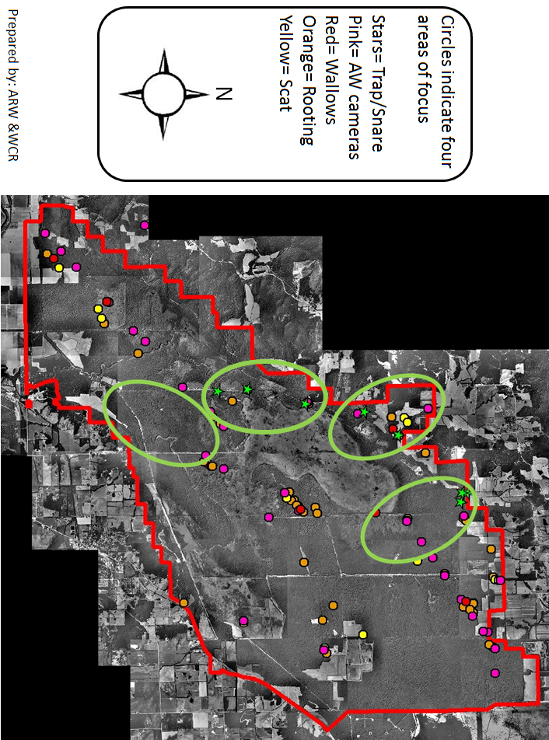

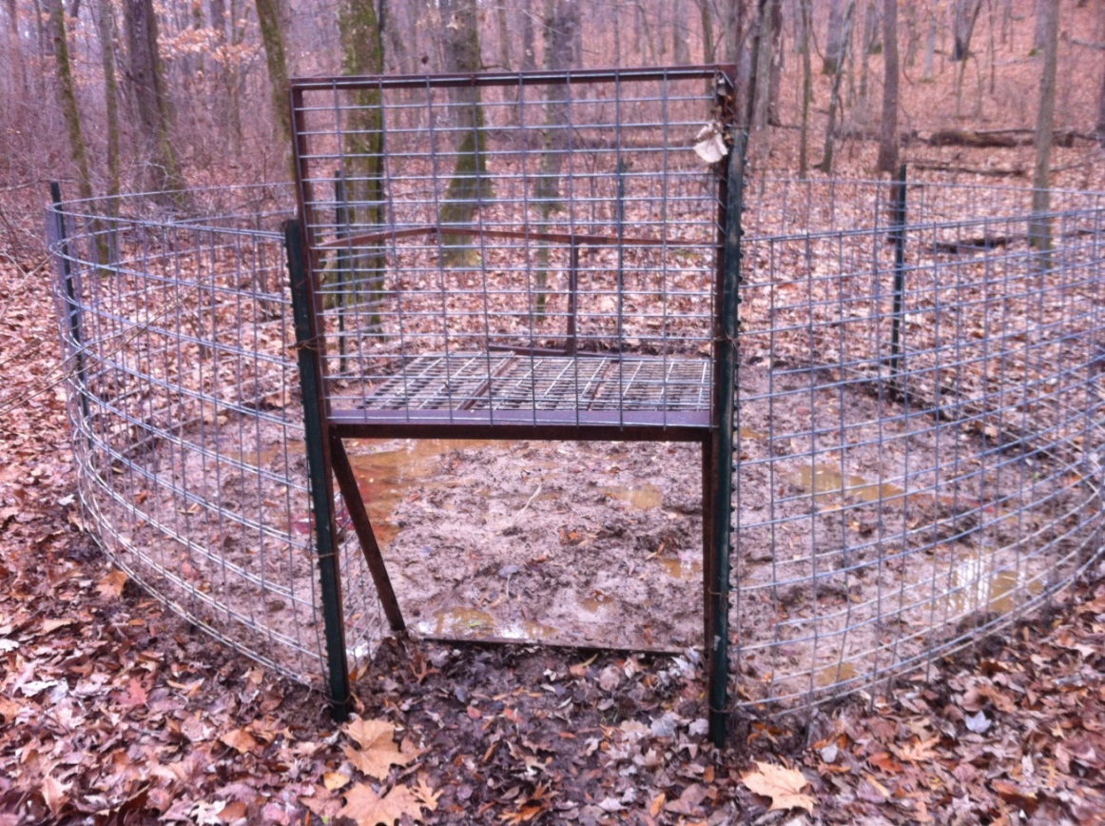
Figure 2.—Coral trap with rooter gate.

Figure 3—C- gate corral trap.
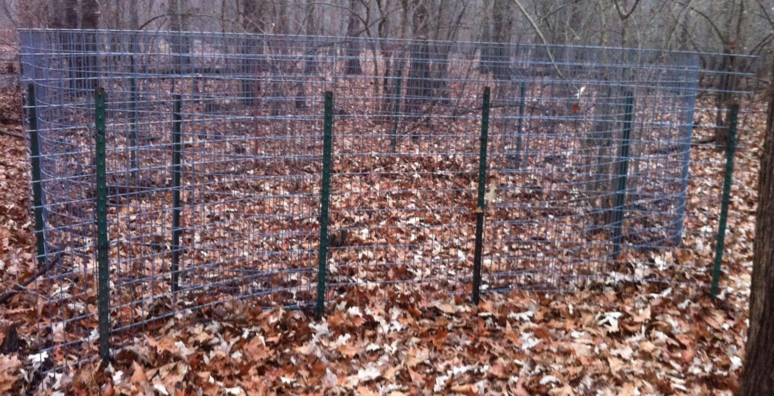
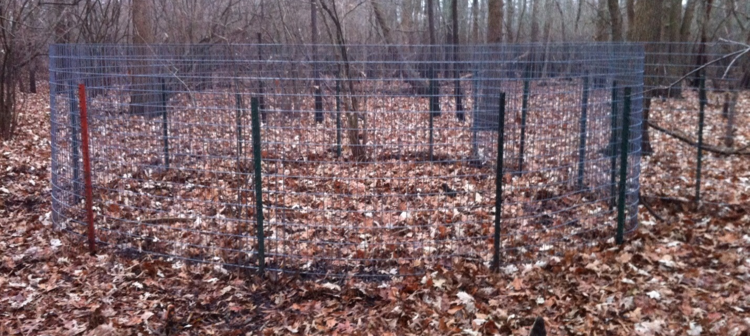
Figure 4.—Snare set.

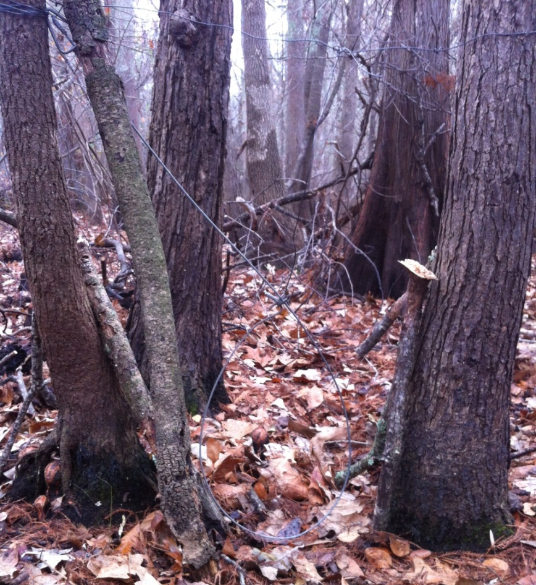

5. Application
- Expanded knowledge on the efficacy of feral swine removal techniques in Bottomland Hardwood Forest habitats of Southeast Missouri.
- Development of site-specific feral swine management plans for each natural area
- Population genetic assessment and disease surveillance of feral swine at study sites
- Morphological and biological description of feral swine in Southeast Missouri
- Interagency cooperation on feral swine management

6. Budget Summary
Name: John S. Scheibe

Department: Biology

Name of Proposal: Site-specific Efficacy of Feral Swine Removal Techniques in Southeast Missouri

Item | Amount Requested From GRFC | Total amount requested
Travel and per diem:
Travel, Per Diem (through MDC) |  | 8000.00
Consumable field items (through MDC) |  | 5200.00
Equipment:
Rooter Gate (4 @ $299 ea) | 1196.00
Hog Slammer (C-gate: 4 @ $325 ea) | 1300.00
Fence Posts (6.5 ft heavy duty t-posts. 10/trap @$5.99 ea) | 479.20
Trap panels (4/trap, 4 traps = 16 panels @ $51 ea) | 816.00
Miscellaneous:
Shipping costs for panels and gates (est) | 350.00
Genetic and disease assays (through MDC) |  | 1500.00
Total | 4141.20 | 14700.00
Grand Total |  | 18841.20

7. Budget Justification

- Travel and per diem: Funded through MDC. No funds are requested through GRFC

- Consumable field items: Funded through MDC. No funds are requested through GRFC

- Equipment

The trap panels, gates and fence posts will be used to double the number of traps that are already in place. A major cost associated with this project is time spent traveling from one core area to the next. By increasing the number of traps within each core area, the overall cost of the study increases via cost of the additional traps, but the travel time and costs between core areas does not increase. Thus, trap effort increases dramatically, but cost does not. The purpose of this project is to find that technique that will enable us to control a rapidly expanding population with a minimal expenditure of resources.

  - Rooter Gates. These gates are designed to allow animals to ‘root’ into the trap, following a bait trail. Once the gate closes, animals can no longer exit. The gate is constructed of heavy duty steel tubing, and must withstand forces applied by the hogs as they attempt to escape. One gate is requested for each of 4 rooter gate traps.
  - C-gates. These gates are designed to allow animals to enter continuously, and the gate closes after each animal has squeezed through. Again a bait trail leads through the gate. As above, the gates are heavy duty, but present a different less threatening profile to the hogs. One gate is requested for each of 4 C-gate traps.
  - Fence posts. Steel heavy duty fence posts are used to support the trap panels and prevent the hogs for bending the trap panels over in an attempt to escape. 10 posts are requested for each of the 8 traps, for a total of 80 posts.
  - Trap panels. Trap panels are constructed of 12 ga welded wire. 4 panels are needed for each trap, for a total of 32 panels. The panels must be strong enough to withstand efforts by the hogs to push through.

- Miscellaneous
  - Shipping costs. The rooter gates and trap panels are heavy and bulky. The $350 figure quoted here is based on discussions with several manufacturers and suppliers.
  - Genetic and disease assay kits. Funded through MDC. No funds are requested through GRFC.

8. Biographical Sketch – J. S. Scheibe

Academic Background.--I earned an A.A. degree in Science from Golden West College in California, B.A. and M.A. degrees in Biology from California State University at Fullerton, and a Ph.D. in Biology from the University of New Mexico. While at the University of New Mexico, I completed 45 credit hours in Mathematical Statistics and successfully completed the first Actuarial Exam. After earning my Ph.D. in Biology, I worked for one year as an Assistant Professor at the New Mexico Military Institute. Since 1983, I have been employed by Southeast Missouri State University.
Since 1984, I have published 29 scientific papers in peer-reviewed national and international journals. I co-edited a book on the biology of gliding mammals with Ross Goldingay of Southern Cross University. I have published 11 technical reports for research projects funded by outside state and federal agencies. I have several manuscripts in review, and manuscripts in preparation. I have presented research seminars at 12 universities, and I am adjunct professor of biology at Auburn. Most recently, I was invited to speak in a symposium on Glaucomys sabrinus (northern flying squirrel) at the annual meeting of the American Society of Mammalogists held at the University of Massachusetts in Amherst, and subsequently gave the Keynote address to the Central Plains Society of Mammalogists in 2008. I have directed the research of 64 graduate students, and of these, 7 have completed doctoral degrees, and 2 are nearing completion of the Ph.D. My students and I have worked with the BBC, National Geographic and the Discovery Channel on film projects involving flying squirrels. These programs have been aired internationally.
Scholarly Preparation.— Most of my research has focused on functional morphology and locomotor kinematics, but I have also conducted research using spatial patch occupancy models for highly fragmented populations. My dissertation research concerned community structure of arid land lizards. Thus, I am a broadly trained field biologist with a great deal of experience in both mammals and reptiles. I have done contract work on swamp rabbits since 2000, and periodically I have had contracts for work on bats, turtles, mice and birds. Early in my career I was involved in projects on sea otters, seals, and burros. Both my MA and Ph.D. research projects were ecological in nature, and most of my externally funded research has been field based. I have published extensively in ecological and mammalogical journals. My teaching includes ecology and advanced ecology, and I have taught special topics courses in Ecological Modeling. I have conducted functional ecology / morphometrics research on gliding mammals at the American Museum, National Museum of Natural History, Carnegie Museum of Natural History, Field Museum of Natural History, Los Angeles County Museum of Natural History, Cotton-Powel Museum in Kent, Museum of Southwestern Biology, and the British Museum.
My most recent awards from the GRFC were in 2001, 2002, 2003 and 2005. Those awards resulted in the completion of several manuscripts and projects. The project on locomotor performance in Glaucomys sabrinus is complete and was published in Acta Theriologica in 2006. The project on locomotor performance in Australian gliders is complete and was published in the Journal of Australian Mammalogy in 2008. The landing kinematics project was presented at an invited symposium at the most recent annual meeting of the American Society of Mammalogists, and the manuscript was published as a special feature in the Journal of Mammalogy in 2007. Some of the work funded by the GRFC led to my collaboration with Keith Paskins of the biomimetics program at the University of Bath, and resulted in a paper published in the Journal of Experimental Biology in 2007.
Use of Vertebrate Animals
All feral hogs captured during this project will be removed by US Fish and Wildlife Service personnel. Aerial gunning will be performed by the Missouri Department of Conservation, and use of dogs and shooting will be performed by an independent contractor through the U. S. Fish and Wildlife Service.

Grant History including GRFC awards (J. S. Scheibe):
1983 Competition and life history strategies in age structured lizard populations. Grants and Research Funding Committee, Southeast Missouri State University. $1,800.

1984 The abundance and distribution of small mammals at three sites in southeast Missouri. Missouri Department of Conservation. $4,000.

1987 Climate, competition, and the structure of temperate zone lizard communities. Ecological Society of America. $625.

Climate, competition, and the structure of temperate zone lizard communities. Ecological Society of America. Grants and Research Funding Committee, Southeast Missouri State University. $350.

Nocturnal activity in the southern flying squirrel, Glaucomys volans: a test of the optimal activity hypothesis. Grants and Research Funding Committee, Southeast Missouri State University. $328.

1988 The status of small mammal populations in Ozark Upland, Ozark Lowland, and Mississippi Flood Plain habitats. Missouri Department of Conservation. $2775.

1993 A faunal survey of the Wappapello Engineers Training Site. U. S. Army Corps of Engineers Research Laboratory. $15,200. Funded.

1994 A faunal survey of the Wappapello Engineers Training Site. U. S. Army Corps of Engineers Research Laboratory. $17,400. Funded.

1995 A faunal survey of the Wappapello Engineers Training Site. U. S. Army Corps of Engineers Research Laboratory. $17,400. Funded.

1996 A faunal survey of the Wappapello Engineers Training Site. U. S. Army Corps of Engineers Research Laboratory. $35,000. Not funded.

1996 The functional morphology of gliding mammals. Grants and Research Funding Committee, Southeast Missouri State University. $4251.65. Funded.

1996 The functional morphology of gliding mammals. Sabbatical Leave Research Funding. $3968. Funded.

1997. Kinematics and functional morphology of mammalian gliding. National Science Foundation RUI proposal. $137,085 over 3 years. Not funded.

1998 A faunal survey of the Wappapello Engineers Training Site. U. S. Army Corps of Engineers Research Laboratory. $23,428. Funded.

1998 The cost of transport in Petaurus breviceps. Grants and Research Funding Committee, Southeast Missouri State University. $5000. Funded

1999 Acoustic and mist net surveys of Myotis sodalis and Myotis grisecens at 5 sites in Missouri. U. S. Army Corps of Engineers Research Laboratory. $343,000. Not funded.

2000 A preliminary analysis of evolutionary relationships among the Anomaluridae. PI: Dr. Rex Strange. Grants and Research Funding Committee. $1900. Funded

2000 Force plates and leaping. PI: Dr. John Tansil. $2500. Funded.

2000 The distribution and abundance of Swamp Rabbits (Sylvilagus aquaticus) in Southeast Missouri. Missouri Department of Conservation. $27,300. Funded.

2001 Locomotor performance in Glaucomys sabrinus in Alaska. Grants and Research Funding Committee. $3107. Funded.

2001 Locomotor performance in Australian Gliders. Grants and Research Funding Committee. $4807. Funded.

2002 Landing kinematics and peak forces during landing in northern flying squirrels, Glaucomys sabrinus. Grants and Research Funding Committee. $5212. Funded.

2003. Foraging and activity strategies in southern flying squirrels. Grants and Research Funding Committee. $5072. Funded.

2004. Passive acoustic sampling of bats in Southeast Missouri. Missouri Department of Conservation Wildlife Diversity Fund. $8,500. Not funded.

2005 Predation as a Selective Agent in the Evolution of Mammalian Gliding. Grants and Research Funding Committee. $ 5348. Funded.

2005. Establishment of Water Quality Baseline Data and Trend Analysis in Big Oak Tree State Park. Missouri Department of Natural Resources Water Protection Program, Nonpoint Source Implementation (319) Proposal. $400,000 over 4 years. Co-principle investigator with Diane Wood and John Kraemer. Not funded.

2010 Distribution of swamp rabbits in Southeast Missouri. Missouri Department of Conservation. $85,000. Funded 2010 through 2012.
2012 An evaluation of the commercial and recreational harvest of paddlefish (Polyodon spathula) in Missouri. $25,402 With Dave Herzog, Trish Yasger, Quinton Phelps, Ivan Vining, Michael S. Taylor and Ryan Hupfeld
2012 Recolonization of New Madrid and Mississippi Counties by swamp rabbits following the Bird’s Point Levvee Breach. $ 45,000. Funded, Missouri Department of Conservation.
2013 American Eel Movement and Habitat Use in the Middle Mississippi River. $ 24,000. With Dave Herzog, Trish Yasger, Quinton Phelps, Ivan Vining, Michael S. Taylor and Ryan Hupfeld. Funded, Missouri Department of Conservation.
2013 Lake Sturgeon Population Dynamics in the Upper Mississippi River. $ 18,000. With Dave Herzog, Trish Yasger, Quinton Phelps, Ivan Vining, Michael S. Taylor and Ryan Hupfeld. Funded, Missouri Department of Conservation.
2013 A Comparison of Side Channel Fish Communities in the Middle Mississippi River. $ 18,000. With Dave Herzog, Trish Yasger, Quinton Phelps, Ivan Vining, Michael S. Taylor and Ryan Hupfeld. Funded, Missouri Department of Conservation.
2013 Site specific control strategies for feral hogs on Mingo National Wildlife Refuge. $ 14,700. Funded, Missouri Department of Conservation.

